**CHAPTER-1**

**INTRODUCTION**

**1.1 INTRODUCTION:**

Restaurant management systems have become even more state-of-the art over the past few years. Thanks to technological updates, it has become all the more important for those in the hospitality industry to stay up to date to ensure the most profitable restaurant operations.

This includes the various activities that are carried out in a restaurant to run the business, from produce purchasing to preparation of food, staff shift schedules, housekeeping, menu updates, customer service, accounting, website and social media management, reporting, and of course customer orders and tariff values.

Knowledge is an important element for restaurant success, especially when it comes to systems and procedures. A modern restaurant management system is a great way to streamline your operations. It will also reduce overheads and increase your daily sales turnover using effective customer acquisition methods.

If you’re in the beginning stages of looking for a restaurant management system, this comprehensive guide provides answers to your multiple questions and concerns. Let's start by taking a look at five important questions, and evaluating your particular restaurant business..

**1.2 SCOPE OF THE PROJECT**

The project aims to develop an online restaurant management system that facilitates efficient table booking and management. It will provide a platform for customers to access restaurant services and for administrators to oversee and streamline restaurant operations. The system will focus on optimizing restaurant activities and transitioning them to the online domain to meet the growing demand for high-tech services.

.

**1.3 OBJECTIVE**

* Design an effective Restaurant table booking and management system.
* Streamline and automate restaurant operations to meet the needs of today's tech-savvy generation.
* Provide a platform for maintaining customer information and enhancing their dining experience.
* Enable restaurant owners to grow their business by leveraging online services.
* Enhance the overall customer experience and operational efficiency in the restaurant industry.

**1.4 EXISTING SYSTEM:**

* In the existing manual System, many restaurants have a lot difficult to manage the business such as customer reservation table. If the customer books the Table and later wants to cancel the booking, he is permitted to do this only within a specific time period. By using manual booking it is difficult for the staff to keep the correct customer information and may lose the customer information. The customer is also given the facility to view the status of the booking to determine if it is ready.

.

**1.4.1 EXISTINGSYSTEM DISADVANTAGES:**

* User cannot view the booked table in person.
* The system limits human interaction.

**1.5 LITERATURE SURVEY**

**Title:** Formal Specification for Online Food Ordering System using Z language.

**Author:** P. Saratha

**Year:** 2017.

**Description:** Natural Language Processing (NLP) directed to ambiguous representation for software requirements. Ambiguity at different levels creates different representation and meaning. This paper reduces the issues of ambiguity levels for the Software Requirements Specification (SRS) using formal methods. The end result shows the effectiveness in specifications through Z language. The Z specification is created for the commercial application of online food ordering system to improve the order details accuracy and efficiency. The stakeholder needs for food ordering system are gathered from the project goal. The system is designed using Unified Modeling Language (UML) illustration of use case diagram. The specification is created for the system behavior to remove the ambiguity. Along with this, Z/EVES tool is used for the evaluation of Z specifications for the demonstration.

**Title:** An Approach for Restaurant Management System during Covid-19.

**Author:** Namrata Singhal, E. Konguvel.

**Year:** 2022.

**Description**: Restaurant industry is growing at a swift pace and keen to strengthen every segment of their business. Although ample attention is being paid in digitalizing the restaurant management systems, not many business proprietors recognise the importance of implementing digital billing software systems within the restaurant. The consumers' experience at any restaurant includes not only the food but also the placing and billing their orders. Billing software systems must be incorporated with additional features that speed up the restaurant services to gain better recognition, by enhancing the consumer's experience in any food chain. It enables customers to login to their account, access rewards, place orders and obtain the entire bill alongside payment options. The aim of this work is to change the traditional way of ordering food at a restaurant”. During the days of Covid-19, everyone wanted to avail contactless service, so when getting to a restaurant we will digitally access the menu and order our food in a contactless manner. Use of digital menu cards will help erode the communication gap between the waiter and the customer and therefore would confirm that the right order is placed. There will be less chances of order getting mixed with another table too. In this work, the restaurant management system is implemented in 8086 Microprocessor Assembly Language Programming (ALP) through EMU8086 emulator which helps in understanding the operation of 8086 Microprocessor.

**Title:** Smart Restaurant System using RFID Technology

**Author:** Jedidiah Harpanahalli, Kevin Bhingradia, Pranav Jain, Jayasudha Koti.

**Year:** 2020.

**Description:** With a move towards a digital India, digitization has to be ensured in all aspects of the society. In this paper a RFID based restaurant management system by using the concepts of open source technologies like Python and Raspberry Pi is presented. This system is introduced as a solution to the bottleneck caused by the cashiers. Focusing on selfservice, the proposed system aims to develop a digital, contactless and secure restaurant environment which will enable patrons to seamlessly Select, Scan and Eat their desired food items. Identification of food items along with the payment is done using Radio Frequency Identification (RFID) technology wherein each food item is marked using adhesive RFID tags, the amount for the same is deducted automatically from the patron’s digital wallet. This results in significant advancement towards automatic management and reduction in manual labour in a restaurant environment.

**Title:**  E-Restaurant: Online Restaurant Management System for Android

**Author:** M. Rajesh,

**Year:** 2015

**Description**: The simplicity and ease of access of a menu are the main things that facilitate ordering food in a restaurant. A Tablet menu completely revolutionizes the patron's dining experience. Existing programs provide an app that restaurants can use to feed their menus into iOS & Android based tablets and make it easier for the diners to flip, swipe & tap through the menu. We here aim to provide the restaurants with a tablet menu that would recommend dishes based on a recommendation algorithm which has not been implemented elsewhere. In addition to this we run the app on an Android based tablet & not on an iOS based tablet which is more expensive alternative. We use a cloud-based server for storing the database which makes it inexpensive & secure.

**Title:** A Peer Review of Feature Based Opinion Mining and Summarization.

**Author**: Parneet

**Year:** 2014**.**

**Description:** Any organization needs to conduct surveys and collect reviews, in order to improve their product quality. There are number of websites which deals with product reviews. All these reviews are nothings but the opinions of people all over the world about different products. These reviews are very huge and difficult to analyze. Opinion mining is a discipline which deals with analysis of such reviews. Feature based or feature level opinion mining is one of the opinion mining tasks. This paper focuses on feature based opinion mining.

**1.6 PROPOSED SYSTEM**

* Online Restaurant management system is the system for manage the restaurant business. After successful login the customer can reserve the table according to the desired time. The main point of developing this system is to help restaurant administrator manage the restaurant business and help customer for online table reservation. The System can efficiently handle and manage various activities of a restaurant and all these activities will be happening under the supervision of the administrator. The businesses in restaurants are now growing constantly.

**1.6.1 PROPOSED SYSTEM ADVANTAGES:**

* Sometimes it happens that the tables get booked soon during festive seasons therefore user can make advance booking using this system.
* It saves user’s time looking out for restaurants.
* It saves business’s resources and expenses.

**CHAPTER 2**

**PROJECT DESCRIPTION**

**2.1 GENERAL**

In a world where convenience and accessibility are highly valued, this online restaurant management system serves as a vital tool for restaurant owners to adapt and thrive in the modern landscape. It not only simplifies daily tasks but also strengthens the bond between restaurants and their customers, ultimately contributing to the industry's growth and customer satisfaction.

**2.2 METHODOLOGIES**

**2.2.1 MODULES NAME:**

**Modules Name:**

* **Vendor Account Management**
* **User Account Management**
* **View Customer Booked Information**
* **Restaurant Table Booking System**
* **Order Status Checking**

**2.2.2 MODULES EXPLANATION:**

1. **Vendor Account Management:**

This module provides an Vendor login interface to control all booking activities in the system.

The Vendor can verify and manage various member details of booking persons.

The Vendor has the authority to update all bookings per day so that next day bookings starts in next day.

1. **User Account Management:**

Users are required to create an account within the system by registering their information.

Once registered, users can log in to access and utilize various services offered by the system, such as table booking and food placement.

1. **View Customer Booked Information:**

This module enables the Vendors to view customer information, including order foods and order date.

Vendors can also access information regarding the specific tables’ customers have placed orders for, streamlining customer service.

1. **Restaurant Table Booking System:**

The system offers a easy accessible of restaurant tables, allowing users to select tables within specific day slots.

Booked tables are visually highlighted in data of customer account, while available tables are displayed in their standard Available option.

Vendors have the capability to review all table booking requests, with ensuring efficient table allocation automatically.

1. **Order Status Checking:**

Users can check the status of their orders, including whether the orders have been approved by the auto process or not.

This feature provides transparency to users regarding the processing of their orders, enhancing the overall user experience.

.

**2.3 TECHNIQUE USED OR ALGORITHM USED**

**2.3.1 EXISTING TECHNIQUE: -**

* **Time-Limited Booking and Manual Tracking:**
* The existing technique for restaurant management is the Manual Table Reservation System. In this system, restaurants rely on manual processes and staff interactions to handle customer table reservations. The staff takes bookings over the phone or in person, records the customer information, and assigns tables based on availability.
* One specific technique used in the existing manual system is "Time-Limited Booking and Manual Tracking." Under this technique, customers are allowed to make table reservations within a specific time period. If a customer wants to cancel a booking, they need to notify the restaurant within the designated cancellation timeframe.
* The staff manually records the customer's reservation details, including the date, time, party size, and any specific requests. They then allocate a table based on availability and customer preferences. The staff manually tracks the status of the booking, whether it is confirmed, pending, or canceled.

**2.3.2 PROPOSED TECHNIQUE USED OR ALGORITHM USED:**

* **Automated Table Allocation (ATA):**
* The proposed technique for the online restaurant management system is the implementation of an Online Table Reservation System. This system aims to provide customers with easy access to book tables in a restaurant, streamlining the reservation process and enhancing the overall dining experience. By leveraging this technique, restaurant owners can efficiently manage table bookings and cater to customer needs effectively.
* One specific technique that can be implemented in the online restaurant management system is "Automated Table Allocation." This technique utilizes algorithms and intelligent software to automatically assign tables to customers based on their preferences, party size, and availability. It optimizes the seating arrangement process and ensures efficient utilization of the restaurant's seating capacity.
* The Automated Table Allocation technique will eliminate the need for manual table assignment, reducing the chances of errors and conflicts. By considering factors such as table capacity, customer preferences (e.g., window seat, smoking/non-smoking area), and previous reservations, the system will allocate the most suitable table for each reservation. This approach enhances customer satisfaction by providing personalized table selections and minimizes wait times.

.

**CHAPTER 3**

**REQUIREMENTS ENGINEERING**

**3.1 GENERAL**

We can see from the results that on each database, the error rates are very low due to the discriminatory power of features and the regression capabilities of classifiers. Comparing the highest accuracies (corresponding to the lowest error rates) to those of previous works, our results are very competitive.

**3.2 HARDWARE REQUIREMENTS**

The hardware requirements may serve as the basis for a contract for the implementation of the system and should therefore be a complete and consistent specification of the whole system. They are used by software engineers as the starting point for the system design. It should what the system do and not how it should be implemented.

* PROCESSOR : DUAL CORE 2 DUOS.
* RAM : 4GB DD RAM
* HARD DISK : 250 GB

**3.3 SOFTWARE REQUIREMENTS**

The software requirements document is the specification of the system. It should include both a definition and a specification of requirements. It is a set of what the system should do rather than how it should do it. The software requirements provide a basis for creating the software requirements specification. It is useful in estimating cost, planning team activities, performing tasks and tracking the teams and tracking the team’s progress throughout the development activity.

* Operating System : Windows 7/8/10
* Platform : Spyder3/ VS code
* Programming Language : Python
* Front End : HTML, CSS
* Framework : Django

**3.4 FUNCTIONAL REQUIREMENTS**

A functional requirement defines a function of a software-system or its component. A function is described as a set of inputs, the behavior, Firstly, the system is the first that achieves the standard notion of semantic security for data confidentiality in attribute-based deduplication systems by resorting to the hybrid cloud architecture.

**3.5 NON-FUNCTIONAL REQUIREMENTS**

**The major non-functional Requirements of the system are as follows**

**Usability**

The system is designed with completely automated process hence there is no or less user intervention.

**Reliability**

The system is more reliable because of the qualities that are inherited from the chosen platform python. The code built by using python is more reliable.

**Performance**

This system is developing in the high level languages and using the advanced back-end technologies it will give response to the end user on client system with in very less time.

**Supportability**

The system is designed to be the cross platform supportable. The system is supported on a wide range of hardware and any software platform, which is built into the system.

**Implementation**

The system is implemented in web environment using Spyder3/VS code software. The server is used as the intellignce server and windows 10 professional is used as the platform. Interface the user interface is based on Django provides server system.

**CHAPTER 4**

**DESIGN ENGINEERING**

**4.1 GENERAL**

Design Engineering deals with the various UML [Unified Modelling language] diagrams for the implementation of project. Design is a meaningful engineering representation of a thing that is to be built. Software design is a process through which the requirements are translated into representation of the software. Design is the place where quality is rendered in software engineering.

**4.2 UML DIAGRAMS**

**4.2.1 USE CASE DIAGRAM**



**EXPLANATION:**

The main purpose of a use case diagram is to show what system functions are performed for which actor. Roles of the actors in the system can be depicted. The above diagram consists of user as actor. Each will play a certain role to achieve the concept.

**4.2.2 CLASS DIAGRAM**



**EXPLANATION**

In this class diagram represents how the classes with attributes and methods are linked together to perform the verification with security. From the above diagram shown the various classes involved in our project.

**4.2.3 OBJECT DIAGRAM**



**EXPLANATION:**

In the above digram tells about the flow of objects between the classes. It is a diagram that shows a complete or partial view of the structure of a modeled system. In this object diagram represents how the classes with attributes and methods are linked together to perform the verification with security.

**4.2.4 STATE DIAGRAM**



**EXPLANATION:**

State diagram are a loosely defined diagram to show workflows of stepwise activities and actions, with support for choice, iteration and concurrency. State diagrams require that the system described is composed of a finite number of states; sometimes, this is indeed the case, while at other times this is a reasonable abstraction. Many forms of state diagrams exist, which differ slightly and have different semantics.

**4.2.5 ACTIVITY DIAGRAM**



**EXPLANATION:**

Activity diagrams are graphical representations of workflows of stepwise activities and actions with support for choice, iteration and concurrency. In the Unified Modeling Language, activity diagrams can be used to describe the business and operational step-by-step workflows of components in a system. An activity diagram shows the overall flow of control.

**4.2.6 SEQUENCE DIAGRAM**



**EXPLANATION:**

A sequence diagram in Unified Modeling Language (UML) is a kind of interaction diagram that shows how processes operate with one another and in what order. It is a construct of a Message Sequence Chart. A sequence diagram shows object interactions arranged in time sequence. It depicts the objects and classes involved in the scenario and the sequence of messages exchanged between the objects needed to carry out the functionality of the scenario.

**4.2.7 COLLABORATION DIAGRAM**



**EXPLANATION:**

A collaboration diagram, also called a communication diagram or interaction diagram, is an illustration of the relationships and interactions among software objects in the Unified Modeling Language (UML). The concept is more than a decade old although it has been refined as modeling paradigms have evolved.

**4.2.8 COMPONENT DIAGRAM**



**EXPLANATION**

In the Unified Modeling Language, a component diagram depicts how components are wired together to form larger components and or software systems. They are used to illustrate the structure of arbitrarily complex systems. User gives main query and it converted into sub queries and sends through data dissemination to data aggregators. Results are to be showed to user by data aggregators. All boxes are components and arrow indicates dependencies.

**4.2.9 Data Flow Diagram**

**Level 0and Level 01**

Book Food with Table

User

User Login

User Finding Foods

**Level 1**

Vendor’s Login

Update Tables to Initial points

Check Status of Tables booking

Vendor’s Adding Foods

**4.2.10 DEPLOYMENT DIAGRAM**



**EXPLANATION:**

Deployment Diagram is a type of diagram that specifies the physical hardware on which the software system will execute. It also determines how the software is deployed on the underlying hardware. It maps software pieces of a system to the device that are going to execute it.

**SYSTEM ARCHITECTURE:**

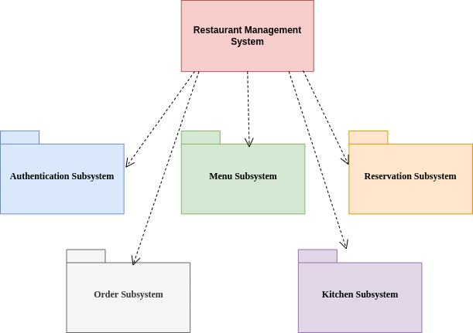

Fig 4.11: System Architecture

**CHAPTER 5**

**DEVELOPMENT TOOLS**

**5.1 Python**

Python is a high-level, interpreted, interactive and object-oriented scripting language. Python is designed to be highly readable. It uses English keywords frequently where as other languages use punctuation, and it has fewer syntactical constructions than other languages.

## 5.2 History of Python

Python was developed by Guido van Rossum in the late eighties and early nineties at the National Research Institute for Mathematics and Computer Science in the Netherlands.

Python is derived from many other languages, including ABC, Modula-3, C, C++, Algol-68, SmallTalk, and Unix shell and other scripting languages.

Python is copyrighted. Like Perl, Python source code is now available under the GNU General Public License (GPL).

Python is now maintained by a core development team at the institute, although Guido van Rossum still holds a vital role in directing its progress.

#### 5.3 Importance of Python

* **Python is Interpreted** − Python is processed at runtime by the interpreter. You do not need to compile your program before executing it. This is similar to PERL and PHP.
* **Python is Interactive** − You can actually sit at a Python prompt and interact with the interpreter directly to write your programs.
* **Python is Object-Oriented** − Python supports Object-Oriented style or technique of programming that encapsulates code within objects.
* **Python is a Beginner's Language** − Python is a great language for the beginner-level programmers and supports the development of a wide range of applications from simple text processing to WWW browsers to games.

#### 5.4 Features of Python

* **Easy-to-learn** − Python has few keywords, simple structure, and a clearly defined syntax. This allows the student to pick up the language quickly.
* **Easy-to-read** − Python code is more clearly defined and visible to the eyes.
* **Easy-to-maintain** − Python's source code is fairly easy-to-maintain.
* **A broad standard library** − Python's bulk of the library is very portable and cross-platform compatible on UNIX, Windows, and Macintosh.
* **Interactive Mode** − Python has support for an interactive mode which allows interactive testing and debugging of snippets of code.
* **Portable** − Python can run on a wide variety of hardware platforms and has the same interface on all platforms.
* **Extendable** − You can add low-level modules to the Python interpreter. These modules enable programmers to add to or customize their tools to be more efficient.
* **Databases** − Python provides interfaces to all major commercial databases.
* **GUI Programming** − Python supports GUI applications that can be created and ported to many system calls, libraries and windows systems, such as Windows MFC, Macintosh, and the X Window system of Unix.
* **Scalable** − Python provides a better structure and support for large programs than shell scripting.

Apart from the above-mentioned features, Python has a big list of good features, few are listed below −

* It supports functional and structured programming methods as well as OOP.
* It can be used as a scripting language or can be compiled to byte-code for building large applications.
* It provides very high-level dynamic data types and supports dynamic type checking.
* IT supports automatic garbage collection.
* It can be easily integrated with C, C++, COM, ActiveX, CORBA, and Java.

**5.5 Libraries used in python**

* numpy - mainly useful for its N-dimensional array objects.
* pandas - Python data analysis library, including structures such as dataframes.
* matplotlib - 2D plotting library producing publication quality figures.
* scikit-learn - the machine learning algorithms used for data analysis and data mining tasks.

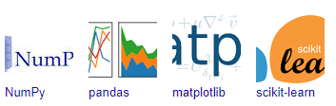

Figure : NumPy, Pandas, Matplotlib, Scikit-learn

**CHAPTER 6**

**IMPLEMENTATION**

**6.1 GENERAL**

**Coding:**

from django.shortcuts import render, redirect

import mysql.connector

import re

import os

from django.core.files.storage import default_storage

from werkzeug.utils import secure_filename

# Create your views here.

mydb = mysql.connector.connect(

host="localhost",

user="root",

password="root",

database="mpwb06_2023"

)

#====HOME PAGE ====

def home(request):

return render(request, 'home.html')

#=== SELLER PAGE ===

def seller_login(request):

msg = ''

if request.method == 'POST':

email = request.POST.get('email')

password = request.POST.get('password')

cursor = mydb.cursor()

cursor.execute("SELECT * FROM seller WHERE email = %s AND password = %s" , (email, password))

account = cursor.fetchone()

if account:

global SellerId, UsedName, EmailId

SellerId = account[0]

UsedName = account[1]

EmailId = account[2]

return redirect('/seller_addre')

else:

msg2 = 'Incorrect username/password! Please login with correct credentials'

return render(request, 'seller_login.html', {'msg': msg})

return render(request, 'seller_login.html')

#======= SELLER - VIEW PROFILE ======

def seller_addre(request):

cursor = mydb.cursor()

cursor.execute("SELECT * FROM seller WHERE email=%s", (EmailId,))

seller_info = cursor.fetchall()

print("seller_info:", seller_info)

cursor.close()

seller_info = seller_info

return render(request, 'seller_addre.html', {'seller_info': seller_info})

# else:

# seller_info = ""

# return render(request, "seller_addre.html", {'seller_info': seller_info})

#====== SELLER - UPDATE PROFILE ======

def seller_addres(request):

if request.method == 'POST' and 'takeid' in request.POST:

takeid = request.POST.get('takeid')

resid = takeid

resname = request.POST.get('resname')

resloc = request.POST.get('resloc')

cursor = mydb.cursor()

cursor.execute("UPDATE seller SET resid=%s, resname=%s, resloc=%s WHERE rid=%s", (resid, resname, resloc, takeid))

mydb.commit()

cursor.close()

msg= "Updated Profile"

seller_info = get_seller_info()

return render(request, 'seller_addre.html', {'msg': msg})

def get_seller_info():

cursor = mydb.cursor()

cursor.execute("SELECT * FROM seller WHERE email=%s", (EmailId,))

seller_info = cursor.fetchall()

cursor.close()

return seller_info

#======== SELLER - ADD FOODS ==============

def seller_addfoods(request):

if request.method == "POST":

fimage = request.FILES['fimage']

fname = request.POST.get('fname')

fdesc = request.POST.get('fdesc')

fnam = secure_filename(fimage.name)

print("fnam:", fnam)

file_path = os.path.join("static/uploads/", fnam)

print("file_path:", file_path)

default_storage.save(file_path, fimage)

cursor = mydb.cursor()

cursor.execute("INSERT INTO foods (resid, resname, resloc, fimage, fname, fdesc, T1, T2, T3) VALUES (%s, %s, %s, %s, %s, %s, %s, %s, %s)",

(get_seller_info()[0][6], get_seller_info()[0][7], get_seller_info()[0][8], file_path, fname, fdesc, 'Available', 'Available', 'Available'))

mydb.commit()

cursor.close()

msg="Food Added Successfully"

return render(request, 'seller_addfoods.html', {'msg': msg})

return render(request, 'seller_addfoods.html')

#========SELLER - ALL BOOKINGS ==========

def seller_bookings(request):

msg = ''

cursor = mydb.cursor()

cursor.execute("SELECT * FROM booktable WHERE resid=%s", (SellerId,))

foods_data = cursor.fetchall()

cursor.close()

return render(request, 'seller_bookings.html', {'foods_data': foods_data})

#====== SELLER - ALL BOOKINGS ========

def seller_updatebookings(request):

msg = ''

cursor = mydb.cursor()

cursor.execute("SELECT * FROM booktable WHERE resid=%s", (SellerId,))

foods_data = cursor.fetchall()

cursor.close()

return render(request, 'seller_updatebookings.html', {'foods_data': foods_data})

#======== SELLER - ALL UPDATE BOOKINGS ========

def seller_updatebookingsss(request):

if request.method =="POST" and 'fid' in request.POST and 'userid' in request.POST and 'resid' in request.POST:

fid = request.POST.get('fid')

userid = request.POST.get('userid')

resid = request.POST.get('resid')

cursor = mydb.cursor()

cursor.execute("DELETE FROM booktable WHERE resid=%s", (resid,))

mydb.commit()

cursor.execute("UPDATE foods SET T1 = 'Available', T2 = 'Available', T3 = 'Available' WHERE T1 IS NOT NULL OR T2 IS NOT NULL OR T3 IS NOT NULL AND resid=%s", (resid,))

mydb.commit()

cursor.close()

return render(request, 'seller_updatebookings.html')

#======= USER PAGE ========

def user_login(request):

msg = ''

if request.method == 'POST':

email = request.POST.get('email')

password = request.POST.get('password')

cursor = mydb.cursor()

cursor.execute("SELECT * FROM user WHERE email = %s AND password = %s" , (email, password))

account = cursor.fetchone()

if account:

global UsedNames, EmailIds

UsedNames = account[1]

EmailIds = account[2]

return redirect('/user_allfood')

else:

msg = 'Incorrect username/password! Please login with correct credentials'

return render(request, 'user_login.html', {'msg': msg})

#========= USER - ALL FOODS DISPLAY ===========

def user_allfood(request):

msg = ''

cursor = mydb.cursor()

cursor.execute("SELECT * FROM foods")

foods_data = cursor.fetchall()

cursor.close()

return render(request, 'user_allfood.html', {'foods_data': foods_data})

#========= USER - BOOK TABLE ===========

def book_table(request):

if request.method == 'POST' and 'resid' in request.POST and 'resname' in request.POST and 'resloc' in request.POST:

resid = request.POST.get('resid')

resname = request.POST.get('resname')

resloc = request.POST.get('resloc')

fid = request.POST.get('fid')

food = request.POST.get('food')

table = request.POST.get('table')

dateandtime = request.POST.get('dateandtime')

cursor = mydb.cursor()

cursor.execute("SELECT * FROM booktable WHERE fid=%s AND food=%s AND `table`=%s AND dateandtime=%s", (fid, food, table, dateandtime))

existing_booking = cursor.fetchone()

if existing_booking:

msg = 'Table already booked for the selected date and time!'

return render(request, 'user_allfood.html', {'fid': fid, 'msg': msg})

cursor.execute("INSERT INTO booktable (resid, resname, resloc, userid, fid, food, `table`, dateandtime) VALUES (%s, %s, %s, %s, %s, %s, %s, %s)",

(resid, resname, resloc, EmailIds, fid, food, table, dateandtime))

mydb.commit()

update_query = "UPDATE foods SET {} = %s WHERE resid = %s AND fname = %s".format(table)

cursor.execute(update_query, (table, resid, food))

mydb.commit()

cursor.close()

return redirect('/user_bookings')

return render(request, 'user_allfood.html')

#======= USER - ALL BOOKINGS =========

def user_bookings(request):

msg = ''

cursor = mydb.cursor()

cursor.execute("SELECT * FROM booktable WHERE userid=%s", (EmailIds,))

foods_data = cursor.fetchall()

cursor.close()

return render(request, 'user_bookings.html', {'foods_data': foods_data})

#==========REGISTER PAGE ==========

def register(request):

msg = ''

if request.method == 'POST':

# Create variables for easy access

selloruser = request.POST.get('selloruser')

usedname = request.POST.get('name')

email = request.POST.get('email')

password = request.POST.get('password')

dob = request.POST.get('dob')

mobile = request.POST.get('mobile')

reg = "^(?=.*[a-z])(?=.*[A-Z])(?=.*\d)(?=.*[@$!%*#?&])[A-Za-z\d@$!#%*?&]{6,10}$"

pattern = re.compile(reg)

cursor = mydb.cursor()

# Check if account exists using MySQL)

query = 'SELECT * FROM {} WHERE email = %s'.format(selloruser)

cursor.execute(query, (email,))

account = cursor.fetchone()

# If account exists show error and validation checks

if account:

msg = 'Account already exists!'

elif not re.match(r'[^@]+@[^@]+\.[^@]+', email):

msg = 'Invalid email address!'

elif not re.match(r'[A-Za-z0-9]+', usedname):

msg = 'Usedname must contain only characters and numbers!'

elif not re.search(pattern,password):

msg = 'Password should contain atleast one number, one lower case character, one uppercase character,one special symbol and must be between 6 to 10 characters long'

elif not usedname or not password or not email:

msg = 'Please fill out the form!'

else:

# Account doesnt exists and the form data is valid, now insert new account into employee table

query2 = 'INSERT INTO {} VALUES (NULL, %s, %s, %s, %s,%s, NULL, NULL, NULL)'.format(selloruser)

cursor.execute(query2, (usedname, email, password, dob, mobile))

mydb.commit()

msg = 'You have successfully registered! Please proceed for login!'

return render(request, '{}_login.html'.format(selloruser), {'msg': msg})

elif request.method == 'POST':

msg = 'Please fill out the form!'

return msg

return render(request, "register.html", {'msg': msg})

**CHAPTER 7**

**SNAPSHOTS**

**General:**

This project is implements like application using python and the Server process is maintained using the SOCKET & SERVERSOCKET and the Design part is played by Cascading Style Sheet.

**SNAPSHOTS**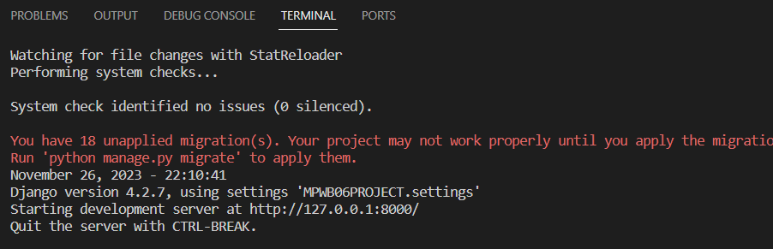

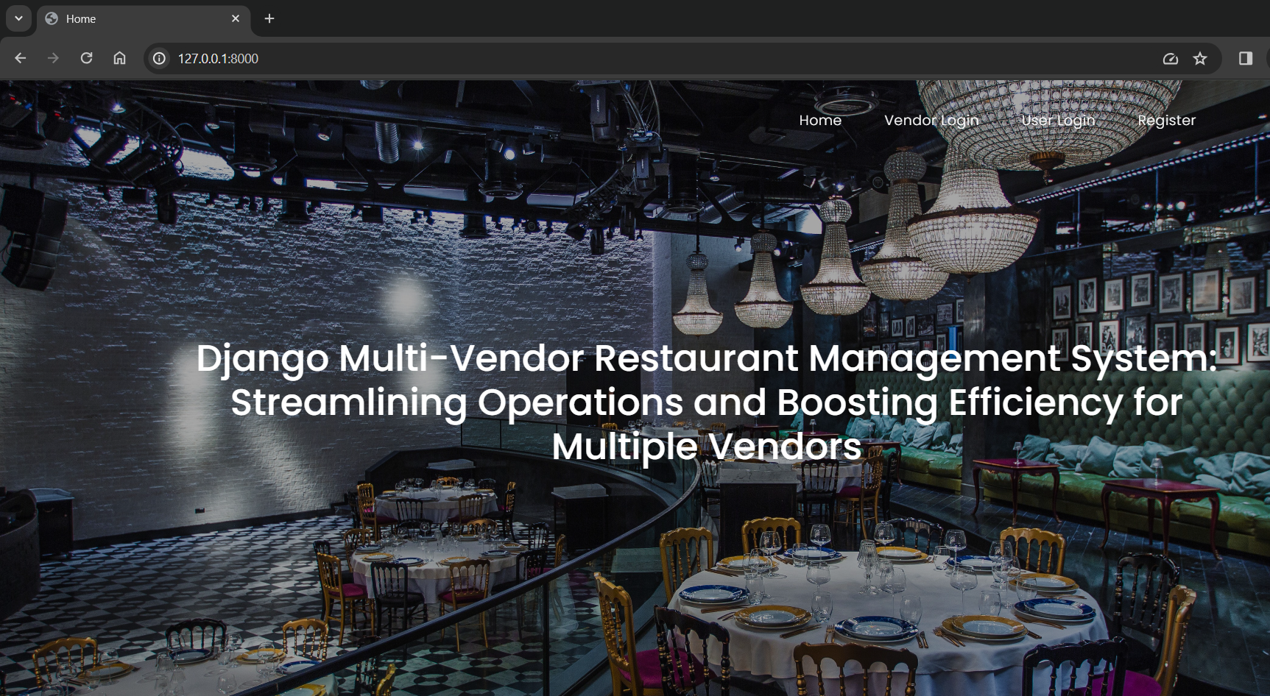

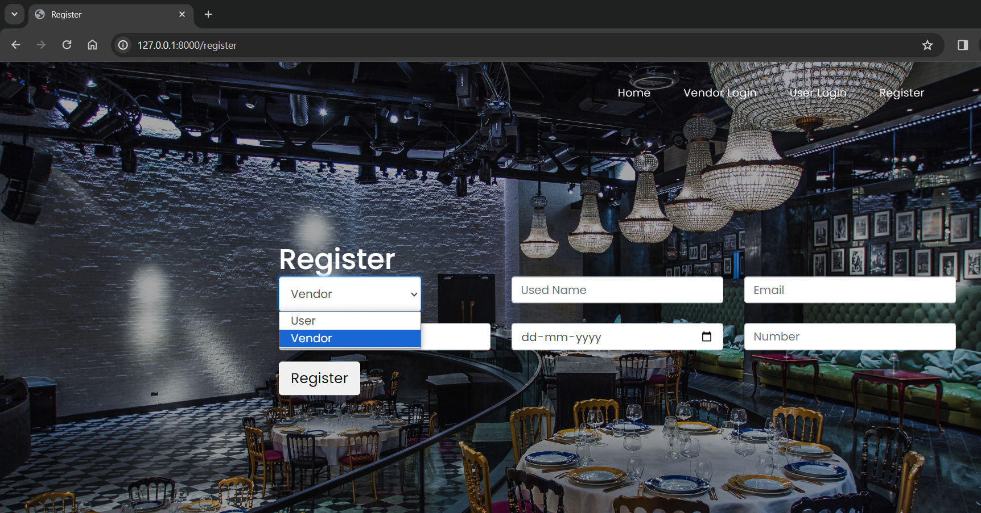

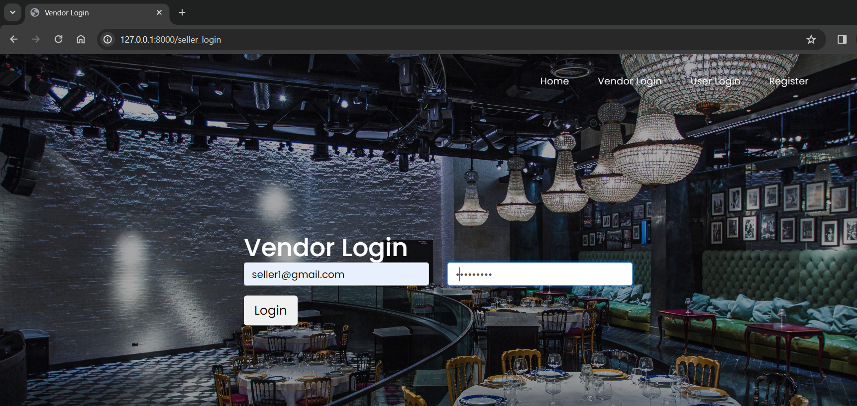

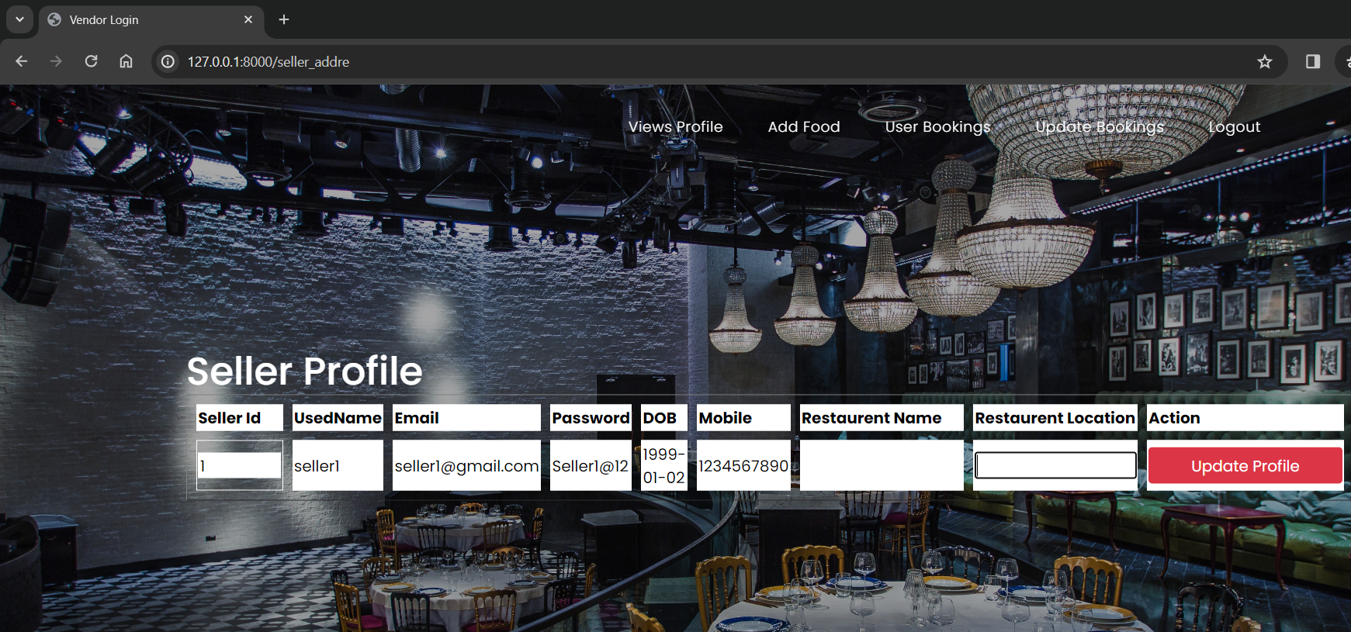

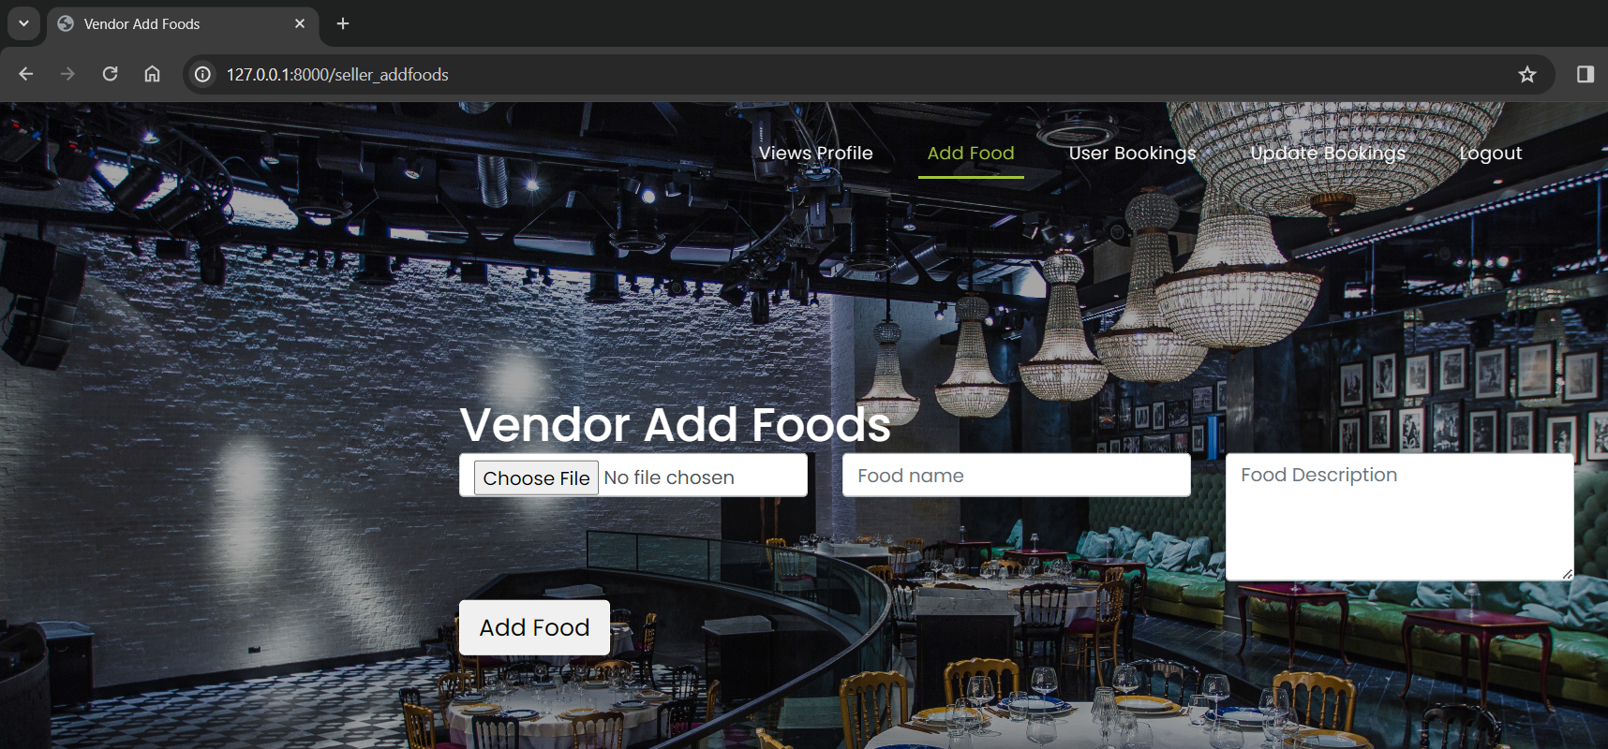

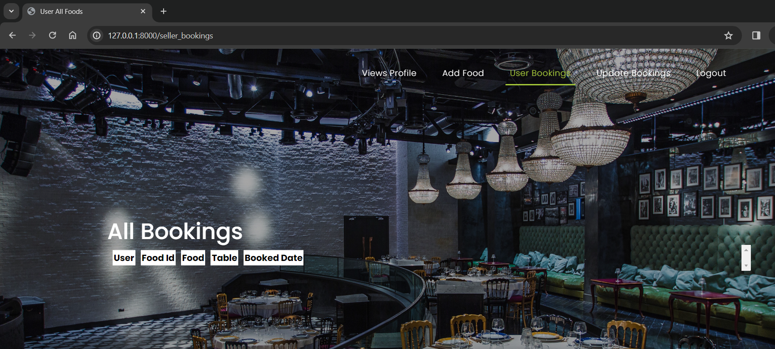

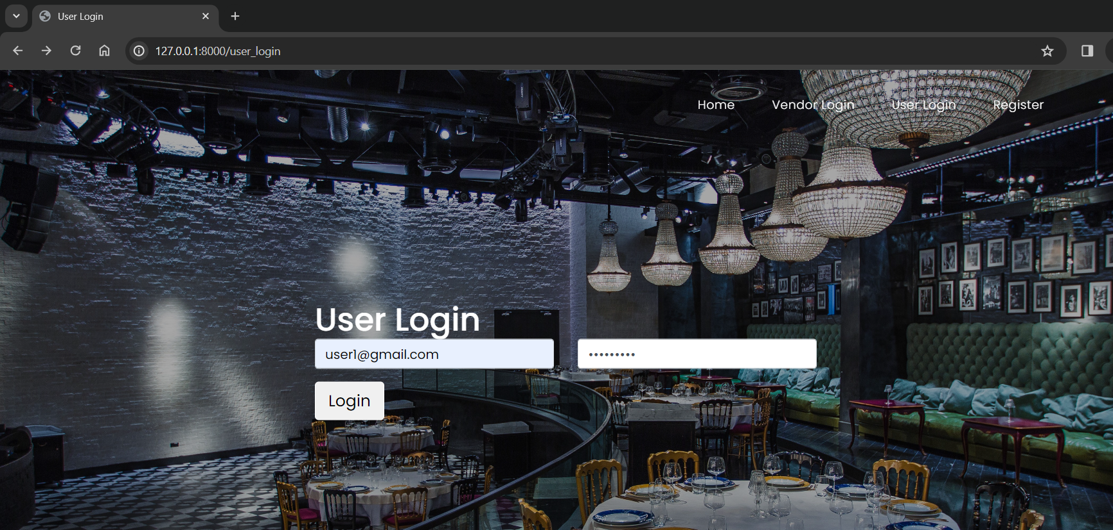

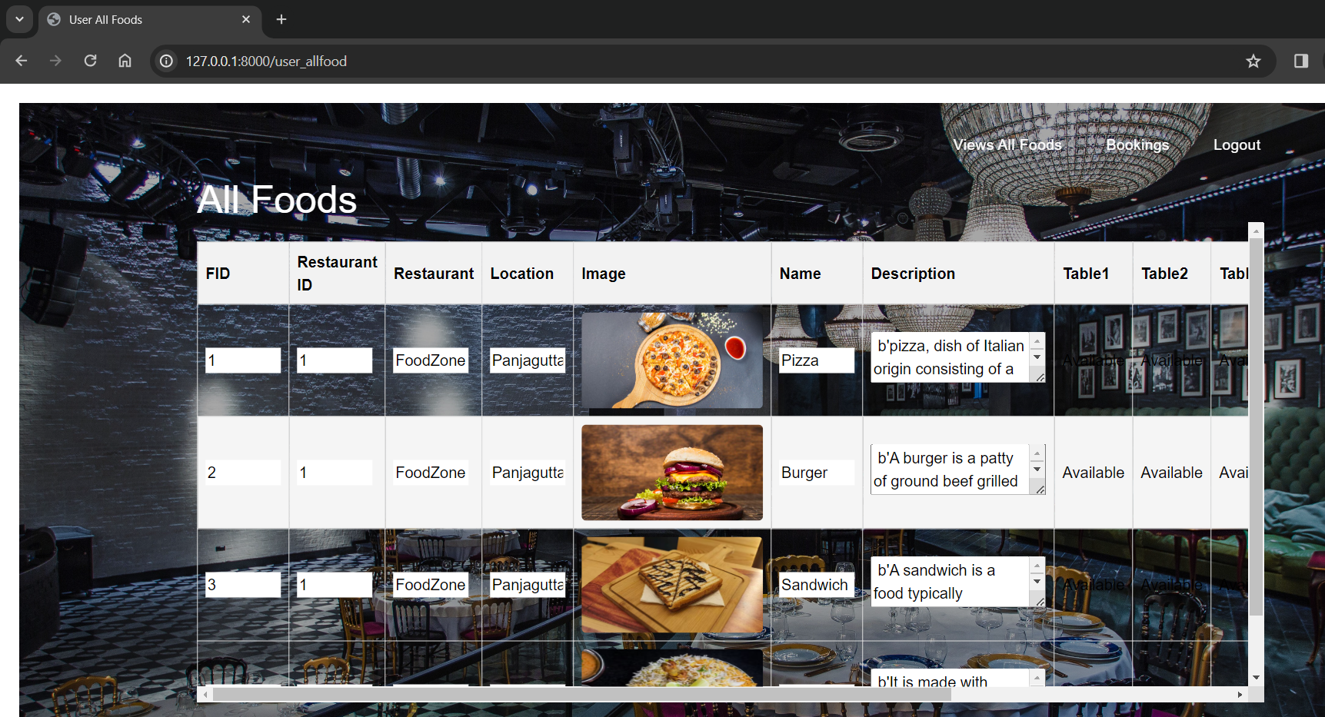

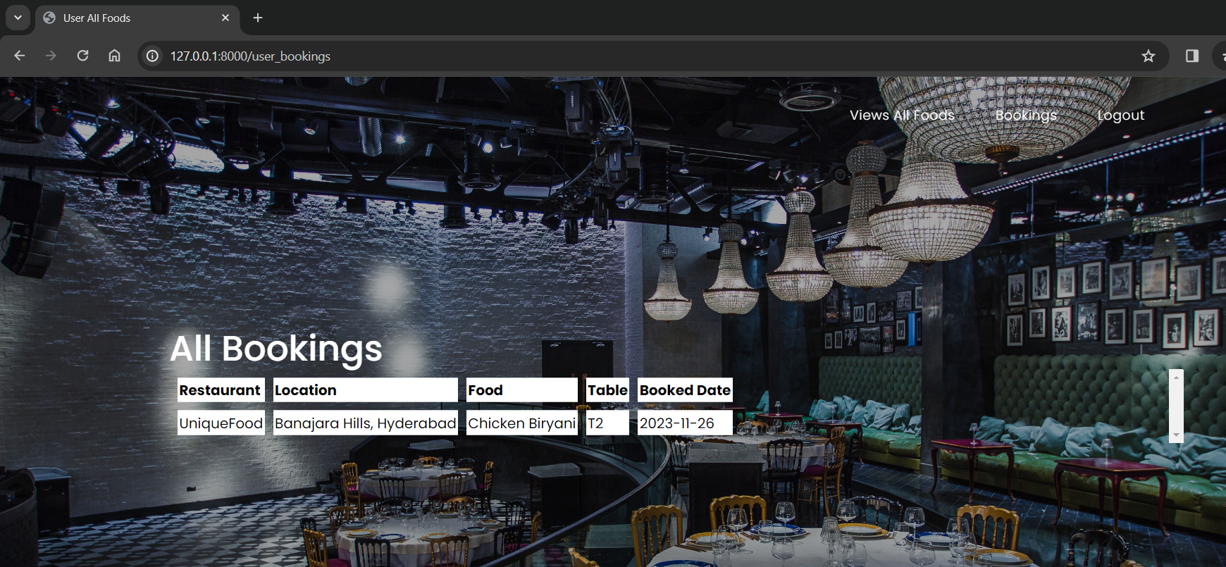

**CHAPTER 8**

**SOFTWARE TESTING**

**8.1 GENERAL**

The purpose of testing is to discover errors. Testing is the process of trying to discover every conceivable fault or weakness in a work product. It provides a way to check the functionality of components, sub assemblies, assemblies and/or a finished product It is the process of exercising software with the intent of ensuring that the Software system meets its requirements and user expectations and does not fail in an unacceptable manner. There are various types of test. Each test type addresses a specific testing requirement.

**8.2 DEVELOPING METHODOLOGIES**

The test process is initiated by developing a comprehensive plan to test the general functionality and special features on a variety of platform combinations. Strict quality control procedures are used. The process verifies that the application meets the requirements specified in the system requirements document and is bug free. The following are the considerations used to develop the framework from developing the testing methodologies.

**8.3Types of Tests**

**8.3.1 Unit testing**

Unit testing involves the design of test cases that validate that the internal program logic is functioning properly, and that program input produce valid outputs. All decision branches and internal code flow should be validated. It is the testing of individual software units of the application .it is done after the completion of an individual unit before integration. This is a structural testing, that relies on knowledge of its construction and is invasive. Unit tests perform basic tests at component level and test a specific business process, application, and/or system configuration. Unit tests ensure that each unique path of a business process performs accurately to the documented specifications and contains clearly defined inputs and expected results.

**8.3.2 Functional test**

Functional tests provide systematic demonstrations that functions tested are available as specified by the business and technical requirements, system documentation, and user manuals.

Functional testing is centered on the following items:

Valid Input : identified classes of valid input must be accepted.

Invalid Input : identified classes of invalid input must be rejected.

Functions : identified functions must be exercised.

Output : identified classes of application outputs must be exercised.

Systems/Procedures: interfacing systems or procedures must be invoked.

**8.3.3 System Test**

System testing ensures that the entire integrated software system meets requirements. It tests a configuration to ensure known and predictable results. An example of system testing is the configuration oriented system integration test. System testing is based on process descriptions and flows, emphasizing pre-driven process links and integration points.

**8.3.4 Performance Test**

The Performance test ensures that the output be produced within the time limits,and the time taken by the system for compiling, giving response to the users and request being send to the system for to retrieve the results.

**8.3.5 Integration Testing**

Software integration testing is the incremental integration testing of two or more integrated software components on a single platform to produce failures caused by interface defects.

The task of the integration test is to check that components or software applications, e.g. components in a software system or – one step up – software applications at the company level – interact without error.

**8.3.6 Acceptance Testing**

User Acceptance Testing is a critical phase of any project and requires significant participation by the end user. It also ensures that the system meets the functional requirements.

**Acceptance testing for Data Synchronization:**

* The Acknowledgements will be received by the Sender Node after the Packets are received by the Destination Node
* The Route add operation is done only when there is a Route request in need
* The Status of Nodes information is done automatically in the Cache Updation process

**8.2.7 Build the test plan**

Any project can be divided into units that can be further performed for detailed processing. Then a testing strategy for each of this unit is carried out. Unit testing helps to identity the possible bugs in the individual component, so the component that has bugs can be identified and can be rectified from errors.

**CHAPTER 9**

**FUTURE ENHANCEMENT**

**9.1 FUTURE ENHANCEMENTS:**

The future scope of this project includes the potential for incorporating advanced AI and machine learning algorithms to optimize restaurant operations further. Additionally, the system can be extended to include features like personalized recommendations, loyalty programs, and real-time analytics for enhanced customer engagement. As the restaurant industry continues to evolve, this platform can adapt to accommodate emerging trends and customer preferences, ensuring its continued relevance and success.

**CONCLUSION**

To conclusion, the creation of an online restaurant management system appears to be a viable remedy for the dynamic restaurant sector. This project aims to improve customer accessibility and happiness by streamlining restaurant operations, namely in the areas of table booking and management. Given the increasing need for advanced technological services, the online platform provides a productive way to streamline and automate restaurant operations.

With its user-friendly interface and information centralization, this system enables restaurant operators to effectively attend to the demands of their patrons. Adopting such technical innovations is crucial for restaurant businesses to succeed in the modern digital era. The main goal of the project is to make it easier for managers to oversee restaurant operations while keeping an eye on things like customer data management and smoother operations.

**REFERENCES**

[1] V. A. Bharadi, Intelligent e-Restaurant using Android OS, Mumbai, 2013.

[2] M. Rajesh, E-Restaurant: Online Restaurant Management, India: International Journal & Magazine of Engineering,, 2015.

[3] A. Bankar, Intelligent Restaurant - Menu Ordering System, India: IOSR Journal of VLSI and Signal Processing(IOSR-JVSP), 2015.

[4] P.Saratha, "Formal Specification for Online Food Ordering System using Z language," Second International Conference on Recent Trends and Challenges in Computational Models, Guindy, 2017.

[5] A. Patil, "SMART RESTAURANT SYSTEM USING ANDROID," International Journal of Technical Research and Applications, India, 2017.

[6] M. Y. Ricky, "Mobile Food Ordering Application using Android OS Platform," EDP Sciences, Indonesia, 2014.

[7] D. V. A. Bharadi, e-Restaurant: Online Restaurant Management System for Android, Mumbai: International Conference & Workshop On Advance Computing, 2013.

[8] Y. Xiaozhou, An intelligent catering service platform based on the “Android+J2EE”, China: 4th International Conference on Advanced Information Technology and Sensor Application, 2015.

[9] P.Saratha, Formal Specification for Online Food Ordering System using Z langu, Guindy: Second International Conference on Recent Trends and Challenges in Computational Models, 2017.

[10] H. Saeed, Near-Field Communication Sensors and Cloud-Based Smart Restaurant Management System, Canada, 2017.

[11] L. Dobrica, Experiencing Native Mobile Health Applications Development, 21st International Conference on Control Systems and Computer Science, Bucharest,, 2017.

[12] M. Y. Ricky, Mobile Food Ordering Application using Android OS Platform, Indonesia: EPJ Web of Conferences 68, 00041,, 2014.